**Part:2 Find the culprits and nail them-debugging script loops.**

**1. Write a code to print the numbers in the array**

**Output: 1234567891011**

**Solution:**

**var numsArr = [ 1, 2, 3, 4, 5, 6, 7, 8, 9, 10, 11];**

**var new_string = "";**

**for (var i = 0; i < 11; i++) {**

**new_string += numsArr[i];**

**}**

**console.log(new_string);**

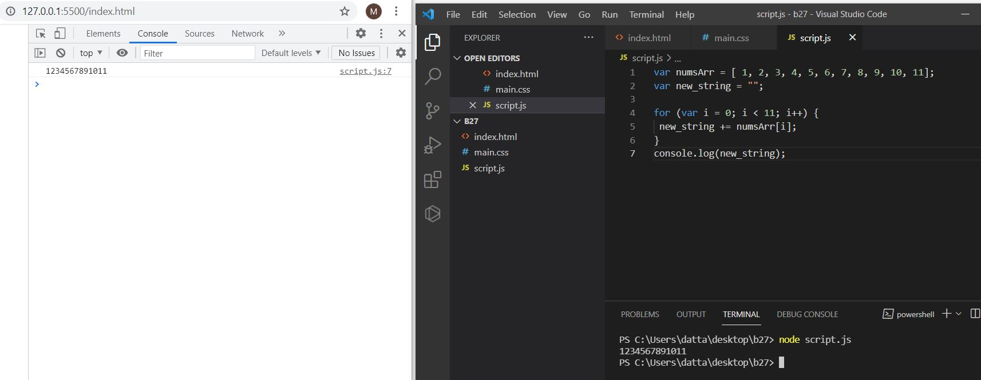

**2. Write a code to print the numbers in the array**

**Output: 1,2,3,4,5,6,7,8,9,10,11**

**Solution:**

**var numsArr = [ 1, 2, 3, 4, 5, 6, 7, 8, 9, 10, 11];**

**var new_string = "";**

**for (var i = 0; i < 11; i++) {**

**new_string += numsArr[i] + ",";**

**}**

**console.log(new_string.slice(0,-1));**

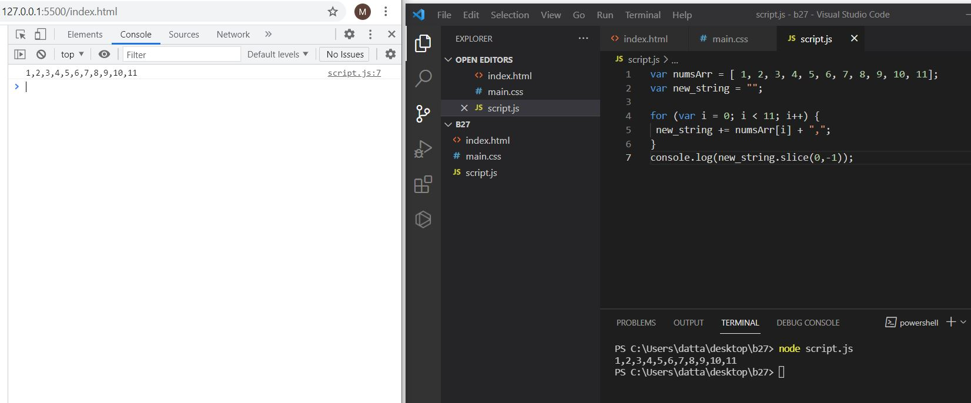

**3. Write a code to print from last to first with spaces (Make sure there is no space after the last element 1)**

**Output: 11 10 9 8 7 6 5 4 3 2 1**

**Solution:**

**var numsArr = [ 1, 2, 3, 4, 5, 6, 7, 8, 9, 10, 11];**

**var new_string ="";**

**for (var i = 10; i >= 0; i-- ) {**

**new_string += numsArr[i] + " ";**

**}**

**console.log(new_string.slice(0,-1));**

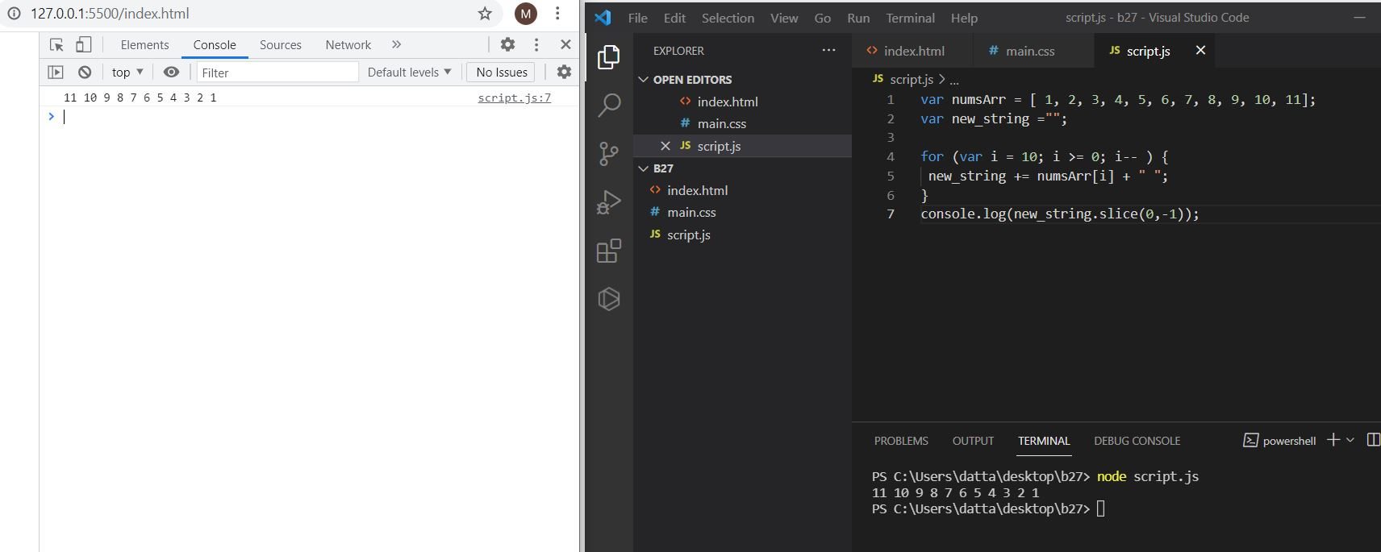

**4. Write a code to replace the array value — If the number is even, replace it with ‘even’.**

**Output:[ 1, “even”, 3, “even”, 5, “even”, 7, “even”, 9, “even”, … ]**

**Solution:**

**var numsArr = [ 1, 2, 3, 4, 5, 6, 7, 8, 9, 10, 11];**

**for (var i = 0; i <=10; i++) {**

**if(numsArr[i] %2 === 0 )**

**{**

**numsArr[i] = "even";**

**}**

**}**

**console.log(numsArr);**

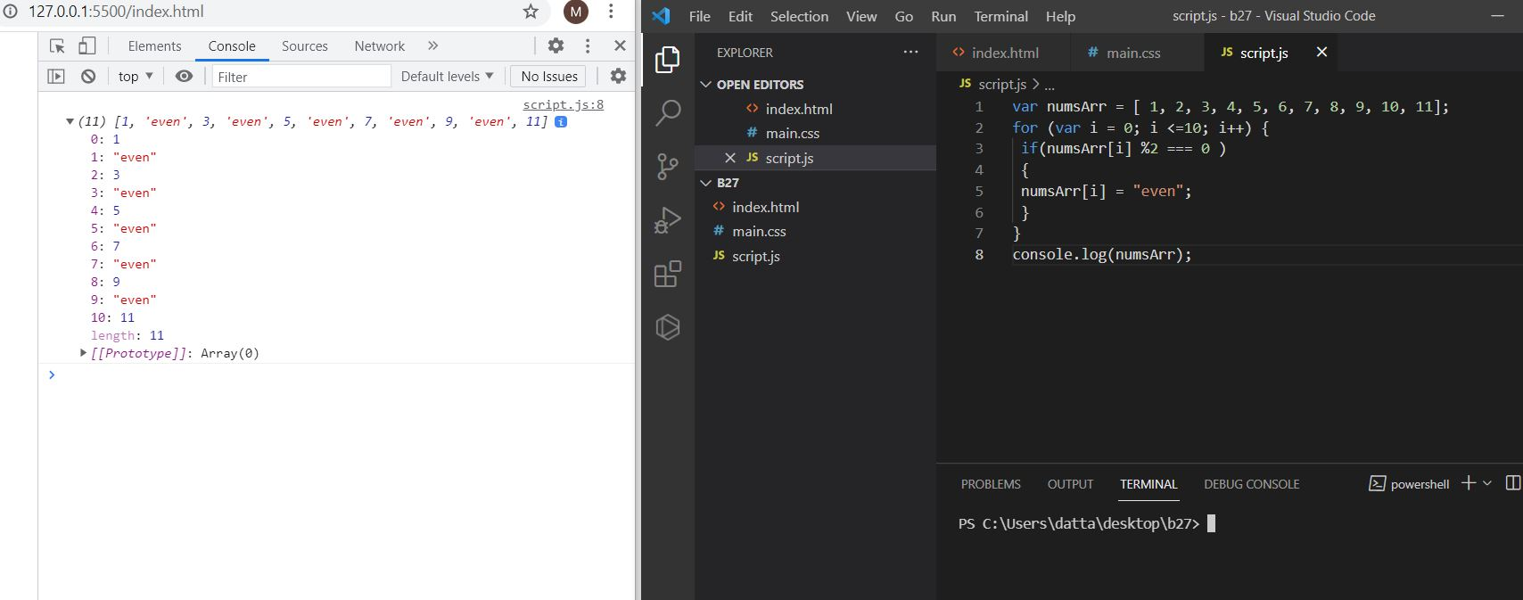

**5. Write a code to replace the array value — If the index is even, replace it with ‘even’.**

**Output: [ “even”, 2, “even”, 4, “even”, 6, “even”, 8, “even”, 10, …]**

**Solution:**

**var numsArr = [ 1, 2, 3, 4, 5, 6, 7, 8, 9, 10, 11];**

**for (var i = 0; i <=10; i++) {**

**if(numsArr[i] %2 !== 0 )**

**{**

**numsArr[i] = "even";**

**}**

**}**

**console.log(numsArr);**

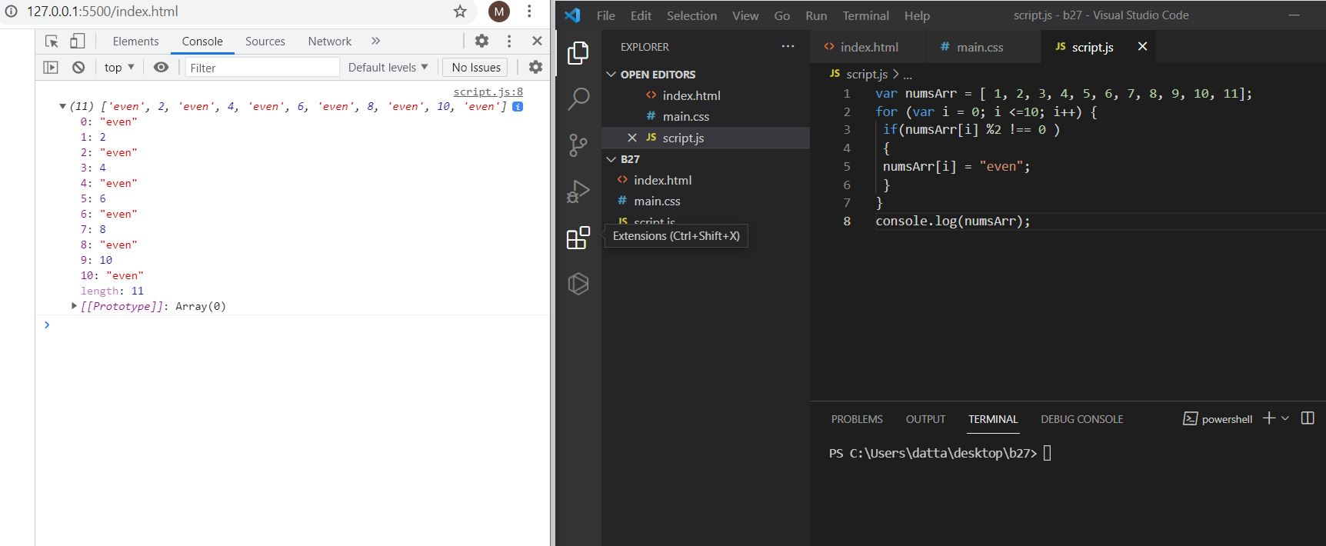

**6. Write a code to add all the numbers in the array**

**Output: 66**

**Solution:**

**var numsArr = [ 1, 2, 3, 4, 5, 6, 7, 8, 9, 10, 11];**

**var sum = 0;**

**for (var i = 0; i <=10; i++) {**

**sum += numsArr[i];**

**}**

**console.log(sum);**

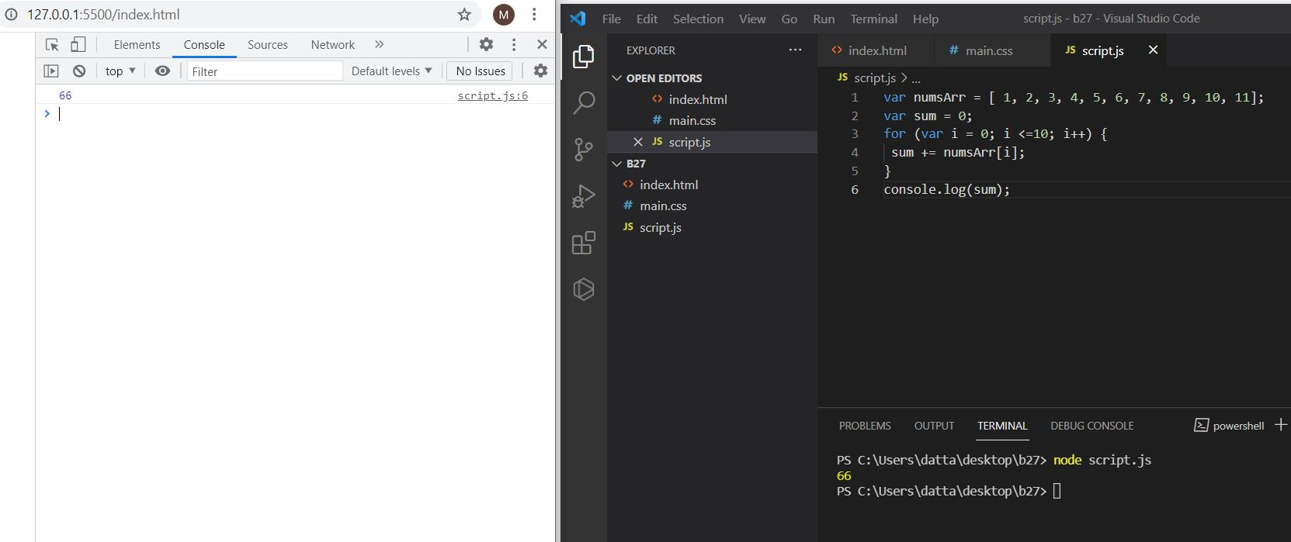

**7. Write a code to add the even numbers only**

**Output: 30**

**Solution:**

**var numsArr = [ 1, 2, 3, 4, 5, 6, 7, 8, 9, 10, 11];**

**var sum=0;**

**for (var i = 0; i <10; i++) {**

**if(numsArr[i]%2===0){**

**sum += numsArr[i];**

**}**

**}**

**console.log(sum);**

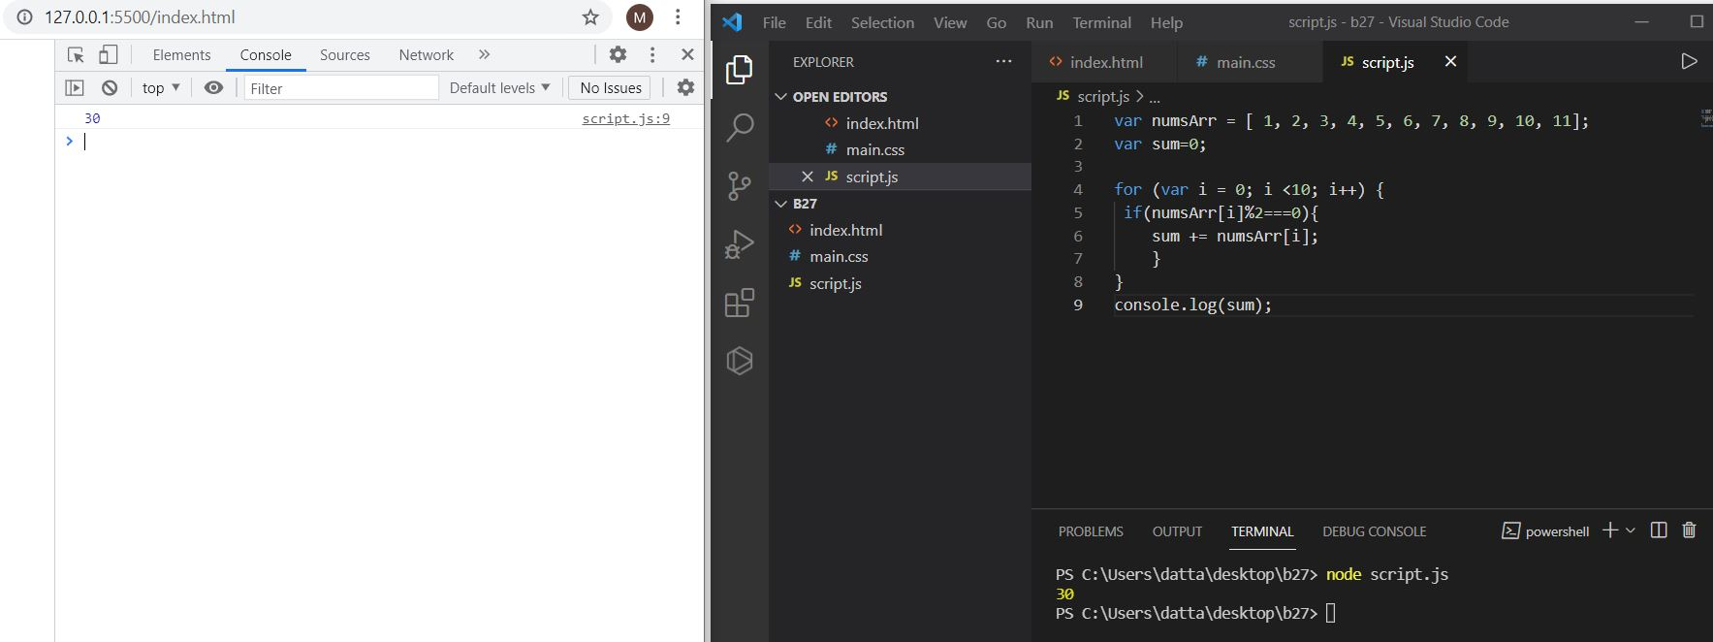

**8. Write a code to add the even numbers and subtract the odd numbers**

**Output: 94**

**Solution:**

**var numsArr = [ 1, 2, 3, 4, 5, 6, 7, 8, 9, 10, 11];**

**var sum=100;**

**for (var i = 0; i <=10; i++) {**

**if(numsArr[i]%2===0)**

**{**

**sum += numsArr[i];**

**}**

**else**

**{**

**sum -= numsArr[i];**

**}**

**}**

**console.log(sum);**

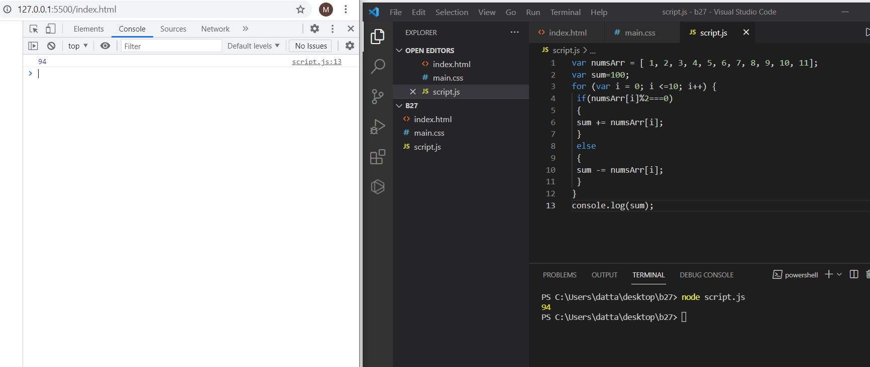

**9. Write a code to print inner arrays**

**Output:Array(5) [ 1, 2, 3, 4, 5 ]**

**Array(6) [ 6, 7, 8, 9, 10, 11 ]**

**Solution:**

**var numsArr = [[1, 2, 3, 4, 5],[ 6, 7, 8, 9, 10, 11]];**

**for (var i = 0; i < numsArr.length; i++){**

**console.log( numsArr[i]);**

**}**

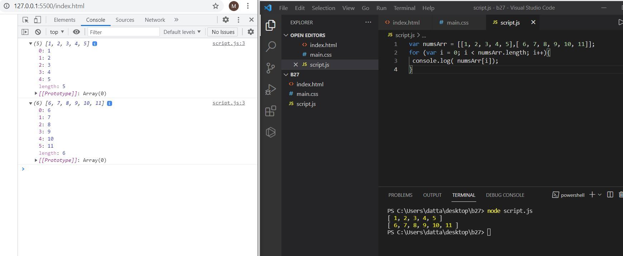

**10. Write a code to print elements in the inner arrays**

**Output: 1234567891011**

**Solution:**

**var numsArr = [[1, 2, 3, 4, 5],[ 6, 7, 8, 9, 10, 11]];**

**var str_all=[];**

**for (var i = 0; i < numsArr.length; i++) {**

**var inner_array = numsArr[i];**

**for(var j = 0 ; j < inner_array.length;j++ )**

**str_all +=inner_array[j];**

**}**

**console.log(str_all);**

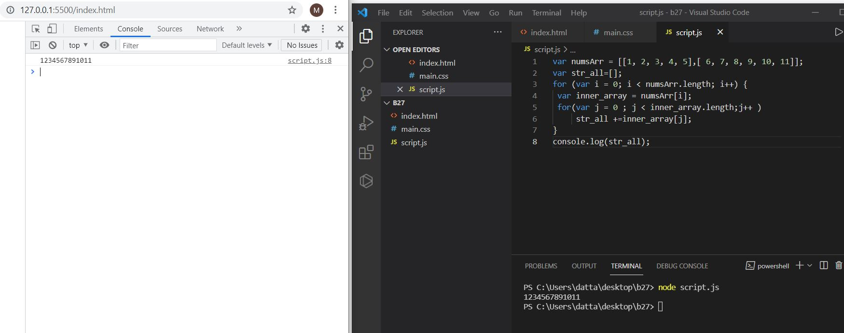

**11. Write a code to replace the array value — If the index is even, replace it with ‘even’.**

**Output: [ [“even”, 2, “even”, 4, “even”], [6, “even”, 8, “even”, 10, …] ]**

**Solution:**

**var numsArr = [[1, 2, 3, 4, 5],[ 6, 7, 8, 9, 10, 11]];**

**for (var i = 0; i < numsArr.length; i++) {**

**var inner_array = numsArr[i];**

**for(var j = 0 ; j < inner_array.length;j++ )**

**if(inner_array[j] %2 !== 0 )**

**{**

**inner_array[j] = "even";**

**}**

**}**

**console.log(numsArr);**

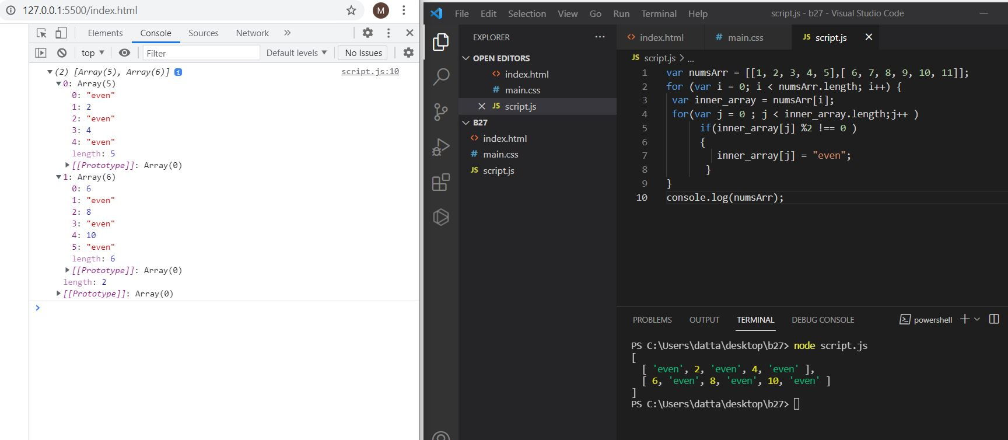

**12. Write a code to print elements in the inner arrays in reverse**

**Output: 11 10 9 8 7 6 5 4 3 2 1**

**Solution:**

**var numsArr = [[1, 2, 3, 4, 5],[ 6, 7, 8, 9, 10, 11]];**

**var str_all="";**

**for (var i = numsArr.length-1; i>=0; i--) {**

**var inner_array = numsArr[i];**

**for(var j = inner_array.length-1; j >= 0 ;j-- )**

**str_all +=inner_array[j] + " ";**

**}**

**console.log(str_all);**

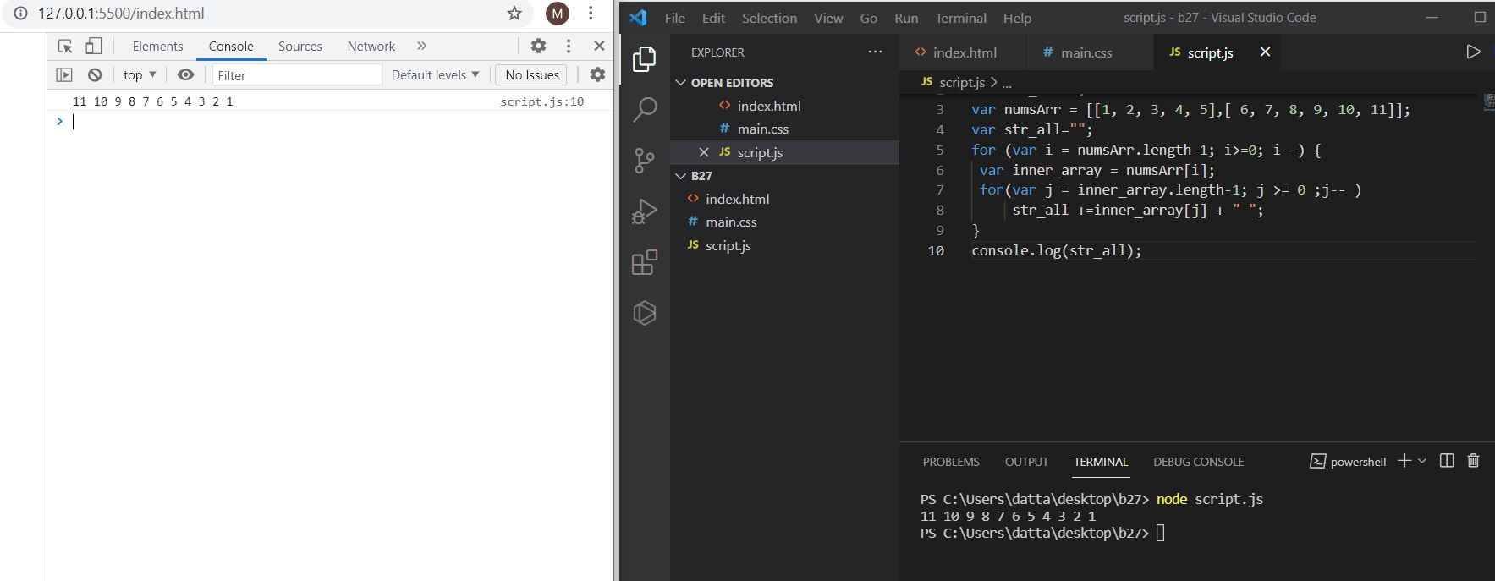

**13. Write a code to add elements in the inner arrays based on odd or even values**

**Output:**

**36**

**30**

**Solution:**

**var numsArr = [[1, 2, 3, 4, 5],[ 6, 7, 8, 9, 10, 11]];**

**var sum_odd=0;**

**var sum_even=0;**

**for (var i = 0; i < numsArr.length; i++) {**

**var inner_array = numsArr[i];**

**for(var j = 0 ; j < inner_array.length;j++ ){**

**if(inner_array[j]%2!==0)**

**{**

**sum_odd += inner_array[j];**

**}**

**else**

**{**

**sum_even += inner_array[j];**

**}**

**}**

**}**

**console.log(sum_odd);**

**console.log(sum_even);**

